A

Project Report on

“Travel blog”

Submitted for the award of the Degree of

B.Tech

In

Lovely Professional University, Punjab



Session : 2023-2024

Submitted By: Submitted To:

Deepshikha pal [Kamalpreet Kaur](mailto:kamalpreetk.cs.19@nitj.ac.in)

Reg. No.: 12217173 Assistant Professor,

Section: KN In LPU

Roll No.: 25

**INTRODUCTION**

This project aims to develop a comprehensive travel vlog application that enhances user experience and engagement. The purpose of this project is to delve into the captivating realm of travel vlogging and craft a cutting-edge application that serves as a gateway to immersive travel experiences. Our journey begins by delving into the essence of travel itself – the exploration of new landscapes, the embrace of diverse cultures, and the profound connections forged along the way. Through the lens of technology, we seek to harness the power of storytelling to ignite the spark of wanderlust in the hearts of our users.

Travel vlogging has become a popular way for people to share their travel experiences and inspire others. This project aims to develop a user-friendly mobile application that caters to both travel vloggers and viewers. The application will provide features to facilitate the creation, sharing, and discovery of travel vlogs.

In the era of digitalization, travel vlogs have emerged as a popular medium for sharing travel experiences and exploring diverse cultures through online platforms. This project aims to develop a comprehensive travel vlog application that enhances user experience and engagement.

In a world fueled by wanderlust and digital connectivity, the allure of travel transcends geographical boundaries, inviting us to embark on adventures that enrich our souls and broaden our horizons. With the rise of social media and online content creation, the art of storytelling has found a new canvas in the form of travel vlogs. These captivating digital narratives not only transport viewers to exotic locales but also inspire them to embark on their own journeys of life.

At the heart of our endeavor lies the desire to create a platform that transcends the boundaries of traditional travel media, offering users a multifaceted experience that seamlessly blends entertainment, education, and inspiration. Our vision is to empower travelers – both seasoned adventurers and armchair explorers alike – to share their tales of wanderlust with the world, fostering a global community bound by a shared passion for discovery.

In our exploration of the landscape of travel vlogging, we draw upon a rich tapestry of literature and research, illuminating the myriad facets of this dynamic field. From studies analyzing the psychology of wanderlust to examinations of the evolving landscape of digital media consumption, we seek to unravel the complexities of travel vlogging and distill its essence into a transformative user experience.

As we embark on this odyssey of creativity and innovation, we are guided by a steadfast commitment to excellence and authenticity. With each line of code and pixel of design, we strive to imbue our application with the spirit of adventure, inviting users to embark on a journey of self-discovery and exploration.

Together, let us chart a course towards new horizons, where every click of the mouse and tap of the screen unlocks a world of possibilities. For in the boundless expanse of cyberspace, the spirit of adventure knows no bounds, and the journey truly begins where the road ends. Welcome aboard – let the adventure begin.

**Literature Survey**

Extensive research has been conducted in the field of travel vlogging, focusing on various aspects such as content creation, user interaction, and platform features. Existing literature highlights the significance of immersive storytelling, high-quality visuals, and community engagement in successful travel vlogs. Additionally, studies have emphasized the role of user-generated content and social media integration in enhancing the reach and impact of travel vlogging platforms.

Here is review of some relevant applications:

* **YouTube:** A dominant platform for video sharing, including travel vlogs. However, it lacks specific travel-related features and functionalities.
* **NomadList:** A community platform for travelers, offering features like travel planning and recommendations, but not specifically designed for vlogging.
* **BeTravel:** Focuses on booking travel experiences but doesn't specifically cater to travel vlog creation or sharing.
* **Travel + Leisure Set:** An app suite with functionalities for booking travel and creating travel blogs, but video editing and sharing capabilities are limited.

**Central to the success of any travel vlogging application is the quality and authenticity of the content it delivers. Studies have emphasized the importance of immersive storytelling, compelling visuals, and genuine engagement in capturing the attention of audiences and fostering meaningful connections.**

**In addition to content creation, community engagement plays a crucial role in the success of travel vlogging applications. Scholars have explored the dynamics of online communities, examining the role of social media platforms, forums, and online groups in facilitating interaction and collaboration among travelers. Through the lens of network theory and social psychology, researchers have analyzed the formation of online communities, the spread of user-generated content, and the impact of influencer marketing on audience engagement and brand loyalty.**

**Moreover, the literature highlights the evolving nature of technology and its impact on the travel vlogging landscape. With the proliferation of smartphones, drones, and other digital tools, vloggers have unprecedented access to high-quality cameras, editing software, and social media platforms, enabling them to produce professional-grade content with ease.**

**As we navigate the vast expanse of literature surrounding travel vlogging applications, it becomes clear that the future of this dynamic field is ripe with possibilities. From the rise of user-generated content to the advent of immersive technologies, the landscape of travel vlogging is constantly evolving, presenting both challenges and opportunities for researchers, practitioners, and enthusiasts alike. By harnessing the power of storytelling, technology, and community, travel vlogging applications have the potential to inspire, educate, and connect people across borders and cultures, fostering a global community bound by a shared passion for exploration and discovery.**

**Flow of the Work**

**The development process of the travel vlog application involves several key stages:**

* **Planning and Design:**
  + **Define user stories and functionalities.**
  + **Design user interface (UI) mockups for a seamless user experience.**
  + **Develop a detailed technical architecture plan for the application.**
* **Development:**
* **Implement application functionalities using appropriate programming languages and frameworks (e.g., Kotlin/Java for Android, Swift for iOS).**
* **Integrate video recording, editing, and sharing features.**
* **Develop features for location tagging, travel planning integration, and social media sharing.**
* **Testing and Deployment:**
  + **Perform thorough testing on various devices and operating systems.**
  + **Refine the application based on user feedback and testing results.**
  + **Deploy the application on relevant app stores (Google Play Store, Apple App Store).**
* **Maintenance and Updates:**
  + **Continuously monitor application performance and user feedback.**
  + **Regularly release updates with bug fixes and new features.**

**Comparative Analysis**

**A comparative analysis is conducted with existing travel vlogging applications based on various criteria such as:**

* **User Interface: Evaluating the ease of navigation, visual appeal, and accessibility of different features.**
* **Content Quality: Assessing the relevance, originality, and engagement level of the content shared on the platform.**
* **Community Engagement: Analyzing the interaction mechanisms, user feedback channels, and social media integration.**
* **Technical Performance: Comparing the speed, reliability, and scalability of the applications' backend infrastructure.**

**Innovative Features: Identifying unique features or functionalities that differentiate each application from others in the market.**

* **Comparative Analysis with Existing Applications from the Literature**

**In the ever-expanding landscape of travel vlogging applications, a diverse array of platforms vies for the attention of users, each offering unique features, functionalities, and user experiences. In this comparative analysis, we examine several prominent applications identified in the literature, assessing their strengths, weaknesses, and overall suitability for travelers seeking to share their adventures with the world.**

**1. YouTube**

**As one of the largest and most established platforms for user-generated content, YouTube remains a dominant force in the world of travel vlogging. With its vast audience reach, robust monetization options, and powerful analytics tools, YouTube offers unparalleled opportunities for content creators to showcase their adventures and engage with viewers. Additionally, YouTube's algorithm-driven recommendation system helps surface relevant travel content to users, increasing discoverability and audience engagement.**

* **Strengths:**
  + **Wide reach and established user base.**
  + **Diverse monetization options, including ad revenue, sponsorships, and merchandise sales.**
  + **Advanced analytics tools for tracking performance metrics and audience demographics.**
* **Weaknesses:**
  + **High competition and saturation within the travel vlogging niche.**
  + **Limited control over platform algorithms and monetization policies.**
  + **Challenges in standing out among millions of existing travel channels.**
  + **Limited customization options for branding and user experience.**

**2. Instagram**

**Instagram has emerged as a popular platform for visual storytelling, allowing users to share photos and short videos of their travel experiences with a global audience. With its emphasis on visual content and social engagement, Instagram offers a highly immersive and interactive platform for travel vloggers to showcase their adventures and connect with followers. Features such as Instagram Stories, IGTV, and Reels provide additional avenues for creative expression and audience engagement.**

* **Strengths:**
  + **Highly visual and engaging platform.**
  + **Strong emphasis on user-generated content and community interaction.**
  + **Integration with Facebook's advertising platform for targeted promotions.**
  + **Explore page and hashtag search functionality for discovering new travel content.**
* **Weaknesses:**
  + **Limited video duration for standard posts (up to 60 seconds).**
  + **Lack of advanced video editing and monetization features compared to dedicated video platforms.**
  + **Challenges in driving traffic to external websites or monetization channels.**
  + **Algorithm-driven feed may limit organic reach and visibility for new content creators.**

**Conclusion**

**In conclusion, the landscape of travel vlogging applications is characterized by diversity, innovation, and constant evolution. Each platform offers unique features and functionalities tailored to the needs and preferences of travelers, ranging from established social media giants like YouTube and Instagram to niche platforms like Travello and Tripoto. As technology continues to advance and user behavior evolves, the future of travel vlogging applications holds boundless opportunities for creativity, collaboration, and connection. By leveraging the strengths of existing platforms and embracing emerging technologies, travel vloggers can continue to inspire, educate, and delight audiences around the world, one adventure at a time.**

**Conclusion**

**Conclusions and Future Directions**

In the ever-evolving landscape of travel vlogging applications, our comparative analysis has shed light on the diverse array of platforms available to content creators and travelers alike. As we reflect on our findings and insights, several key conclusions emerge, paving the way for future directions in research and development within this dynamic field.

**Conclusions:**

Diverse Ecosystem: The ecosystem of travel vlogging applications is characterized by a rich diversity of platforms, each offering unique features, functionalities, and user experiences. From established social media giants like YouTube and Instagram to niche platforms catering specifically to travelers, there is no shortage of options for content creators and audiences to explore.

User Engagement: Across platforms, user engagement emerges as a critical factor influencing the success of travel vlogs. Features such as immersive storytelling, community interaction, and algorithm-driven content discovery play a pivotal role in capturing and retaining the attention of audiences, fostering meaningful connections, and driving organic growth.

Monetization Opportunities: While established platforms like YouTube offer robust monetization options through ad revenue, sponsorships, and merchandise sales, niche travel platforms face challenges in generating revenue and sustaining growth. Future developments in monetization strategies, including subscription models, premium content offerings, and brand partnerships, may hold the key to unlocking new revenue streams and expanding opportunities for content creators.

Emerging Technologies: Platforms leveraging VR/AR experiences offer immersive and interactive storytelling opportunities that transcend traditional media formats, providing users with unparalleled levels of engagement and immersion.

**Future Directions:**

Enhanced User Experience: Moving forward, there is a need to focus on enhancing the user experience across travel vlogging applications. This includes improvements in user interface design, content discovery algorithms, and interactive features to create a more seamless and engaging experience for audiences.

Innovative Content Creation Tools: As content creation becomes increasingly democratized, there is a growing demand for innovative tools and technologies to empower creators to produce high-quality and engaging content. Future developments in video editing software, camera technologies, and storytelling techniques can help content creators elevate their craft and stand out in a crowded landscape.

Community Building and Collaboration: Building vibrant and engaged communities is essential for the long-term success of travel vlogging applications. Future efforts should focus on fostering collaboration, facilitating knowledge sharing, and creating opportunities for interaction among content creators and audiences, thereby fostering a sense of belonging and camaraderie within the community.

In conclusion, the future of travel vlogging applications holds immense promise for innovation, creativity, and collaboration. By embracing emerging technologies, enhancing user experiences, and fostering vibrant communities, we can continue to push the boundaries of storytelling and exploration, inspiring audiences around the world to embark on their own journeys of discovery and adventure.

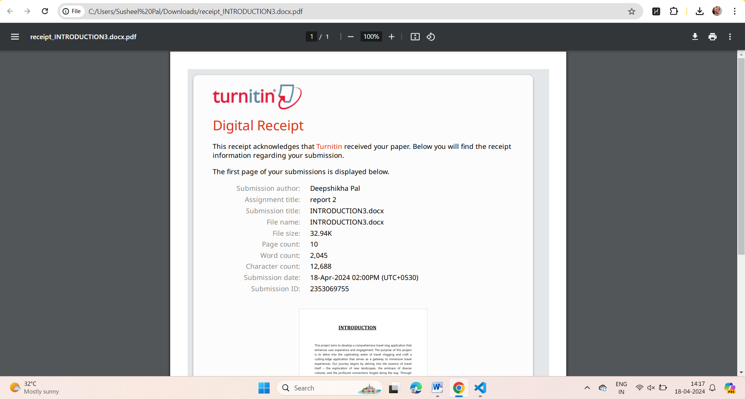

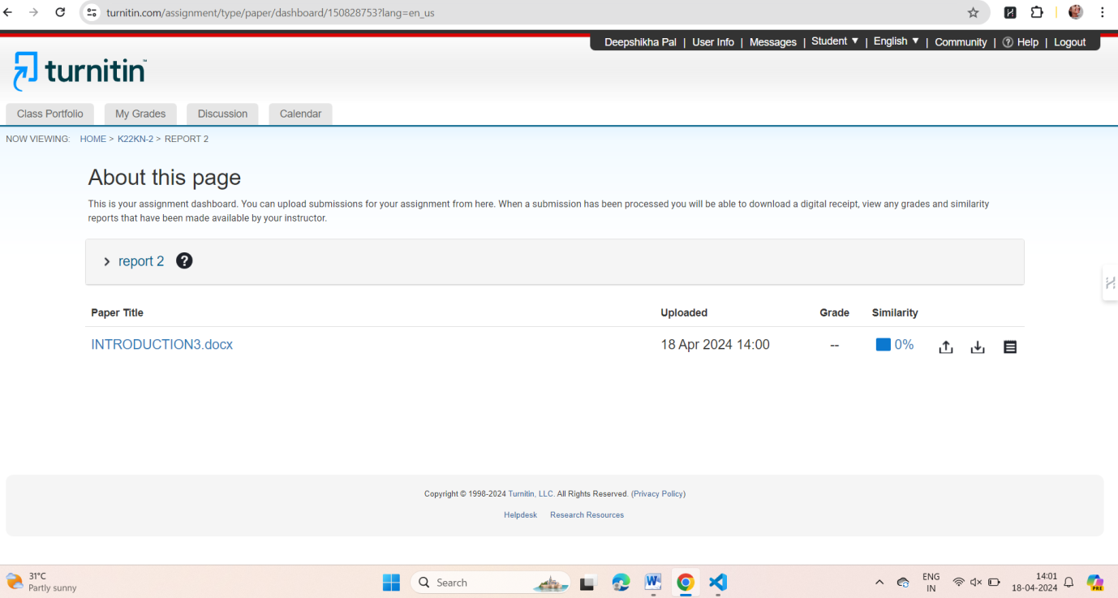



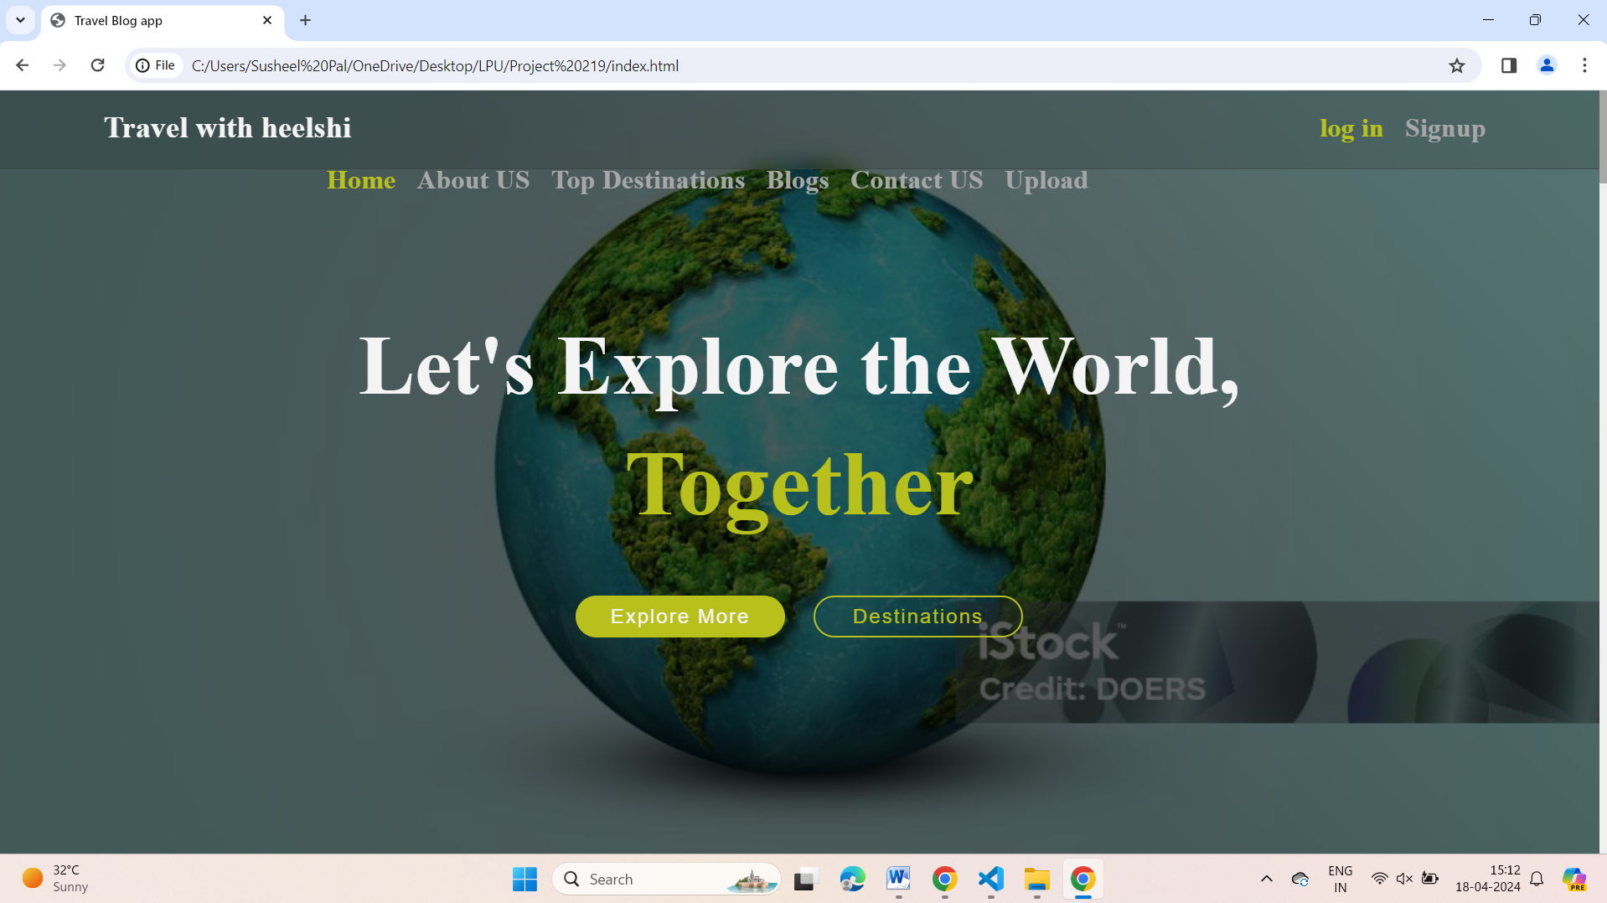

**Thank you !!**